|  |  |  |  |  |
| --- | --- | --- | --- | --- |
| ID | Vorname | Nachname | Straße | PLZ |
| 1 | Max | Mustermann | Bahnhofstraße 3 | 02305 |
| 2 | Frank | Mändel | Goethestraße 5a | 02156 |
| 3 | Lisa | Schubert | Badstraße 27 | 02305 |

|  |  |  |  |
| --- | --- | --- | --- |
| ID | Inhaber_ID | Marke | Kennzeichen |
| 1 | 1 | Audi | PIR-AT-1337 |
| 2 | 2 | BMW | DW-II-11 |
| 3 | 2 | HotWheels | AFK-FM-42 |

Attribute

Schlüssel

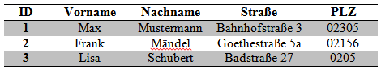

Wert

Datensätze

Foreign key

Schlüssel

